HADOOP COMMANDS

1) start-dfs.sh
This command is used to start the distributed file system.

2) jps
It is used to virtualize what process are running on the background.

3) hdfs dfs -ls /
This command is display the documents present on the directory.

4) hdfs dfs -mkdir /{Dir1,Dir2}
It creates the new directory inside the HDFS.

5) hdfs dfs -mkdir /Dir1/{F1,F2}
This command used to creates the two new folders inside the existing directory.

6) hdfs dfs chmod 777 /Dir :
It used to give permission to read,write and execute.
We can only give the binary values from 0 to 7.

7) cat > filename.txt
It is used to create and write the content in the new file.

8) hdfs dfs -put filename.txt /Dir1/F1
It is used to insert the text file from the local system to the HDFS.
9) hdfs dfs -get /Dir1/F1/filename.txt Desktop/
It is used to download to retrieve the file from the HDFS to the local system.

10) hdfs dfs -cat /Dir1/F1/filename.txt
It is used to view the data stored on the txt file.

11) hdfs dfs -du -h /D1/F1/filename.txt
It is use to check the disk usage of how much size has been captured and replicated.

12) hdfs dfs -rm -r /Dir1/F1/filename.txt
it used to remove the text file or folder from the directory.

13) hdfs dfs -stat %r /Dir1/F1/filename.txt
This command returns the count of the replication.

14) hdfs dfs -setrep 2 /Dir1/F1/filename.txt
This command is used to set the number of replication
So that here the default 3 is changed to the 2 replication

15) hdfs dfs -count /
It returns the count of the dir,folder,files
8 directory 6Files 1955372total block size
For specific directory hdfs dfs -count /Dir1

16) hdfs fsck /
It returns the information about the files,blocks and to check the status of the machine whether it is healthy or not
For the specific files hdfs fsck /dir1/f1/filename.txt -files
For the specific location hdfs fsck /dir1/f1/filename.txt -location
For the specific blocks hdfs fsck /dir1/f1/filename.txt -blocks

OUTPUTS

1)start-dfs.sh
Output:
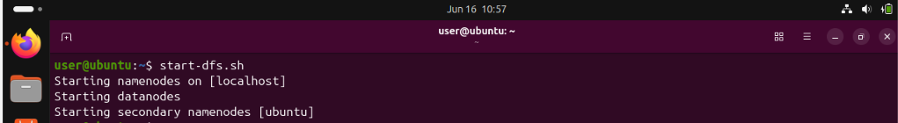
Explanation:
This command is used to start the distributed file system.

2)jps
Output:
Explanation:
It is used to virtualize what process are running on the background.

3)hdfs dfs -ls /
Output:
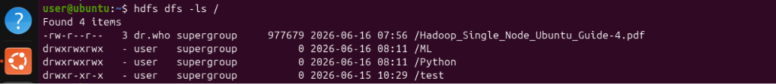
Explanation:
This command is display the documents present on the directory.

4)hdfs dfs -mkdir /{Dir1,Dir2}
Output:
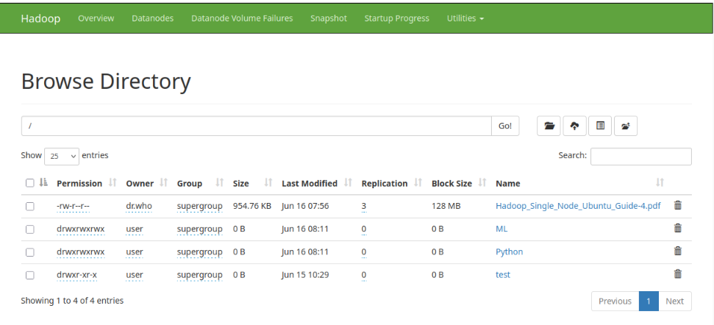
Explanation:
It creates the new directory inside the HDFS.

5)hdfs dfs -mkdir /Dir1/{F1,F2}
Output:
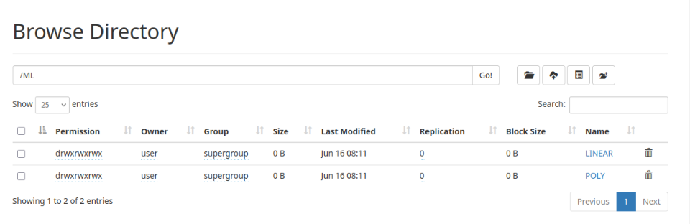Explanation:
This command used to creates the two new folders inside the existing directory.

6)hdfs dfs chmod 777 /Dir
Output:
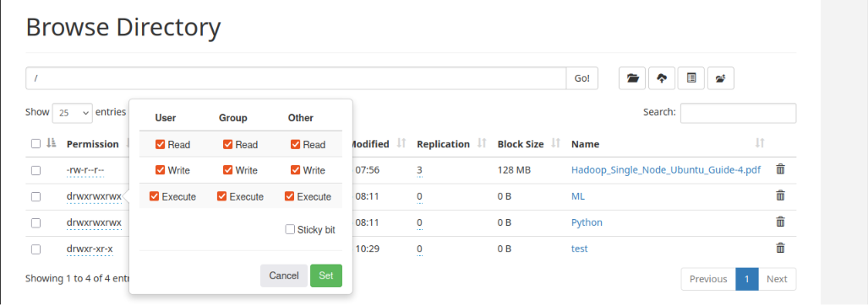
Explanation:
It used to give permission to read,write and execute.
We can only give the binary values from 0 to 7.

7)cat > filename.txt
Output:
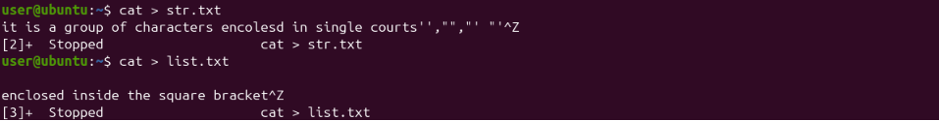
Explanation:
It is used to create and write the content in the new file.

8) hdfs dfs -put filename.txt /Dir1/F1
Output:
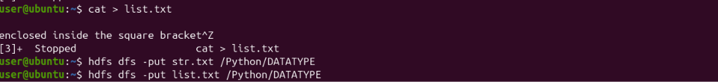
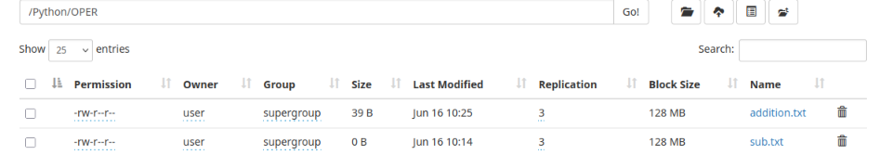
Explanation:
It is used to insert the text file from the local system to the HDFS.

9)hdfs dfs -get /Dir1/F1/filename.txt Desktop/
Output:
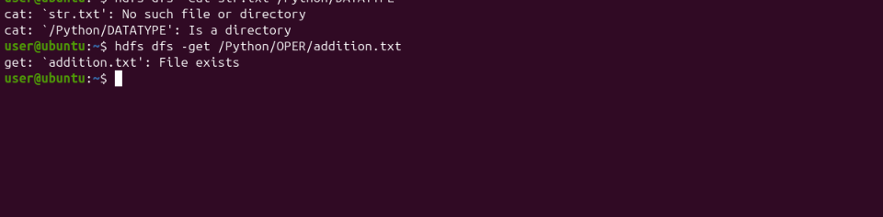
Explanation:
It is used to download to retrieve the file from the HDFS to the local system.

10) hdfs dfs -cat /Dir1/F1/filename.txt
Output:
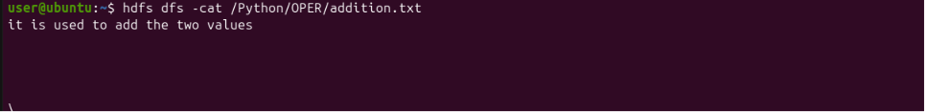
Explanation:
It is used to view the data stored on the txt file.

11)hdfs dfs -du -h /D1/F1/filename.txt
Output:
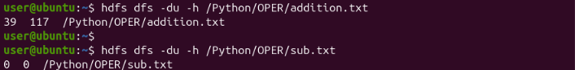
Explanation:
It is use to check the disk usage of how much size has been captured and replicated.

12) hdfs dfs -rm -r /Dir1/F1/filename.txt
Output:
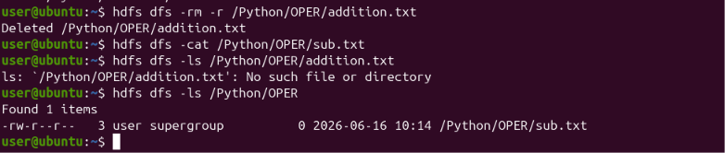
Explanation:
it used to remove the text file or folder from the directory.

13) hdfs dfs -stat %r /Dir1/F1/filename.txt
Output:
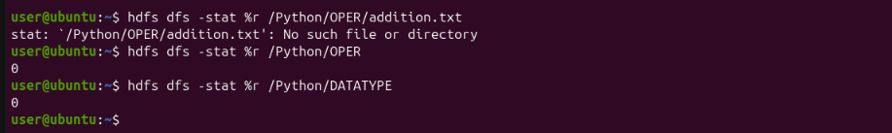
Explanation:
This command returns the count of the replication.
Here the replication is 0 because the it store the block in the file so the replication is only for the files not for the folders.

14) hdfs dfs -setrep 2 /Dir1/F1/filename.txt
Output:
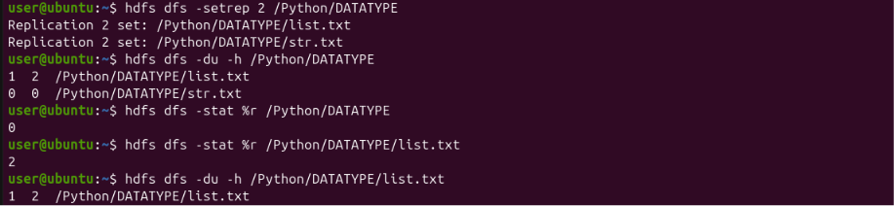
Explanation:
This command is used to set the number of replication.
So that here the default 3 is changed to the 2 replication.

15) hdfs dfs -count /
Output:
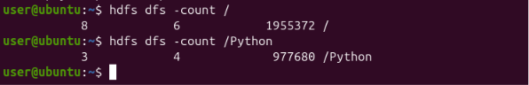
Explanation:
It returns the Count of the dir,folder,files.
8 directory 6Files 1955372total block size
For specific directory hdfs dfs -count /Dir1

16) hdfs fsck /
Explanation:
It returns the information about the files,blocks and to check the status of the machine whether it is Healthy or Not.
For the specific files hdfs fsck /dir1/f1/filename.txt -files
For the specific location hdfs fsck /dir1/f1/filename.txt -location
For the specific blocks hdfs fsck /dir1/f1/filename.txt -blocks
Output: 